**Chapters 1-5 Review/Findings – Document at**

[**https://v2conformance.prometheuscomputing.com/main.html**](https://gcc02.safelinks.protection.outlook.com/?url=https%3A%2F%2Fv2conformance.prometheuscomputing.com%2Fmain.html&data=02%7C01%7Csheryl.taylor%40nist.gov%7Cd16f07a1ee3242ae0a4108d822d72faa%7C2ab5d82fd8fa4797a93e054655c61dec%7C1%7C0%7C637297654901987453&sdata=qSl8JfKrvBipsXtVIZuWUqEVekibiyR7%2Fn7jvn4qbh4%3D&reserved=0)

Red text indicates new findings from re-review

* On Home page:
  + “Use of this material is governed by HL7's **IP Compliance Policy**.”

**IP Compliance Policy should be a hyperlink to** <http://www.hl7.org/legal/ippolicy.cfm?ref=nav>

* Links embedded in text to Figures/Tables/Sections are not active hyperlinks
* Missing this text & link

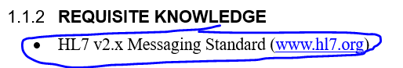

* Hyperlink indicated is not active in on-line doc

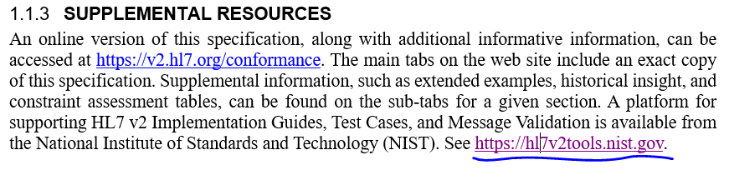

* Footnotes missing in on-line doc, for example
  + In Section 1 (below illustrates these footnotes in Word doc that are missing)



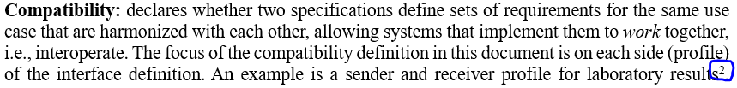



* Spacing not proper here

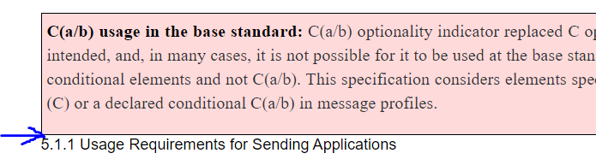

Looks OK now I think.

The online version now looks like this:

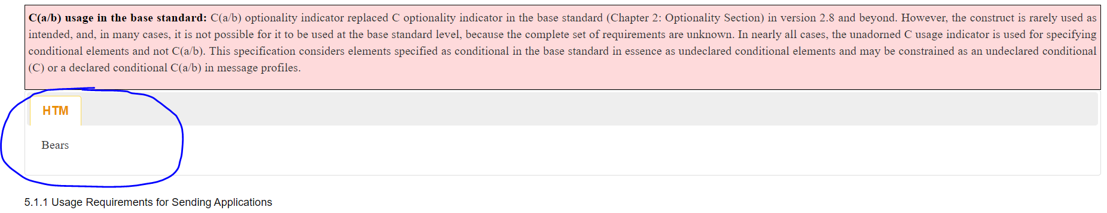

‘Bears’ is debug stuff that is part of me trying to figure out the Word / HTML conversion thing. Don’t worry about it.

* This info is missing in Section 4.3

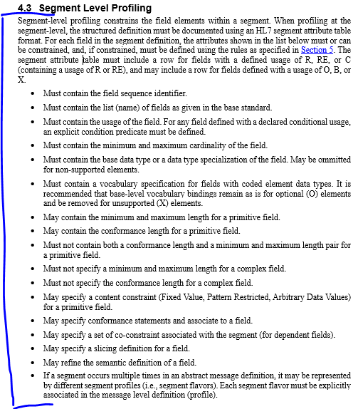

In there now – styling in Word was non-standard

* Bullet points missing in on-line document in this listing in Section 4.1 under Figure 4.1

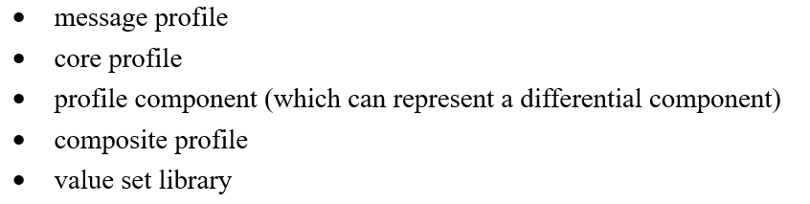

fixed – styling in Word was non-standard

* Formatting of tables often is an issue for ease-of-reading; *for example*, Table 4.1 is easier to read in Word doc as shown here…

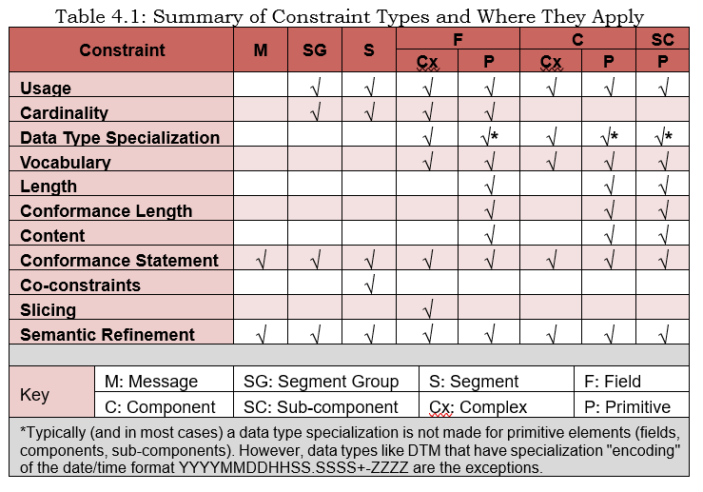

…rather than in on-line doc

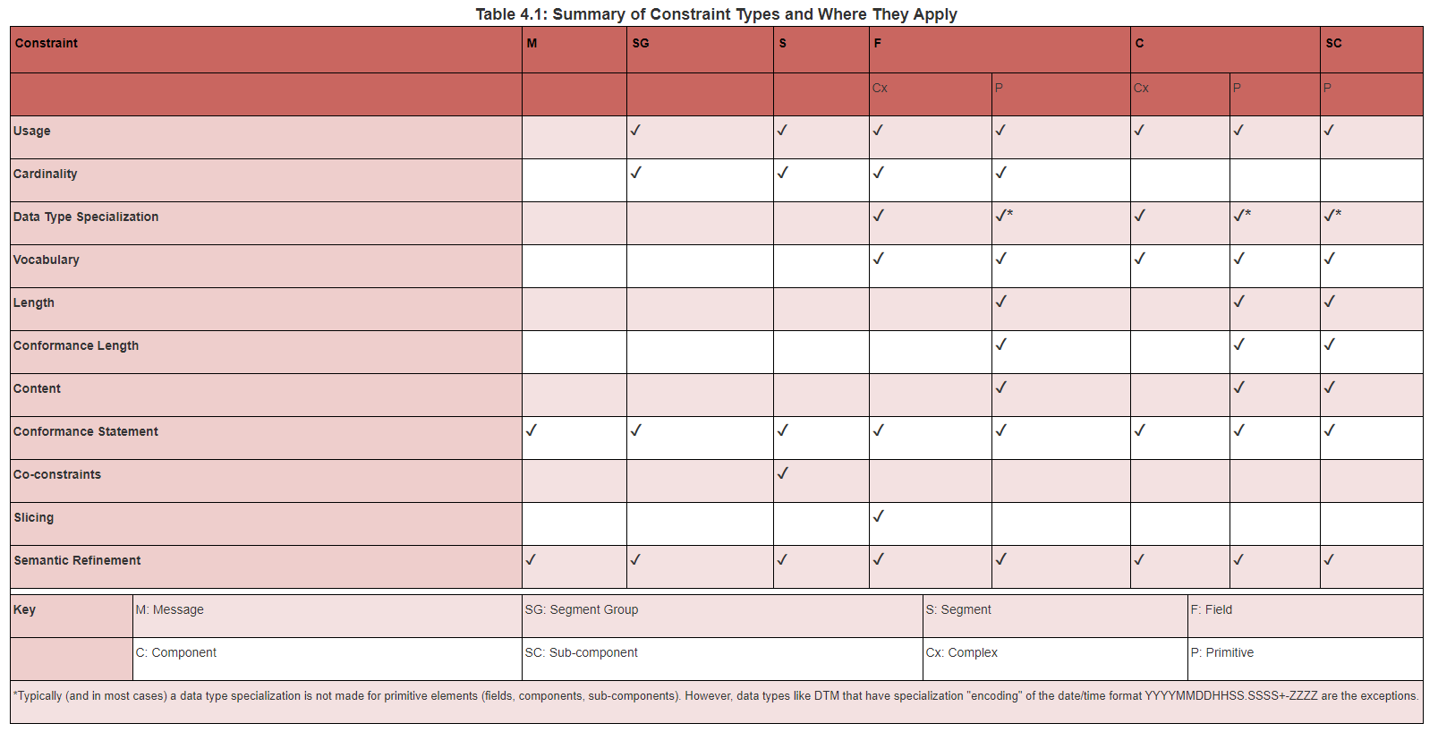

…and Table 5.2 is easier to read in Word doc as shown here…

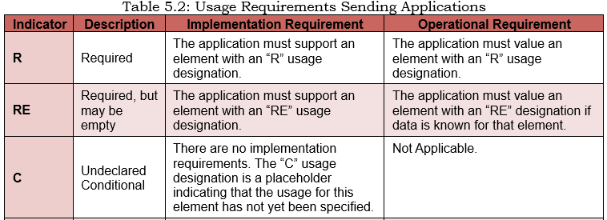

…rather than in on-line doc

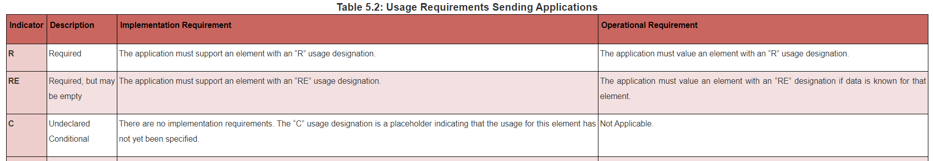

* Indented text in the Word document is not indented in on-line document in section 5.1.3.2

…in Word doc:

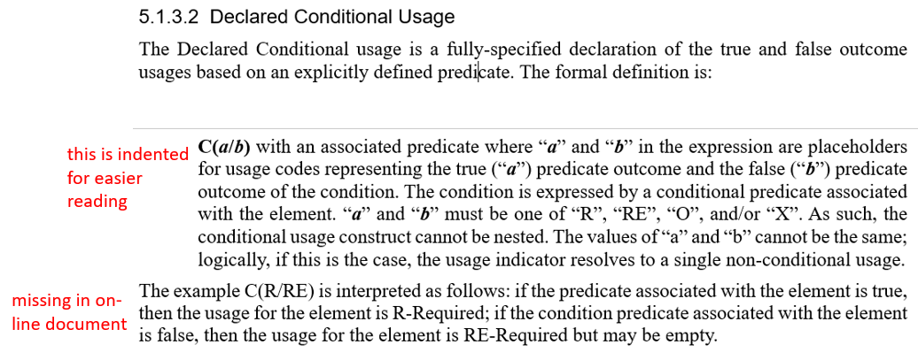

…in on-line doc: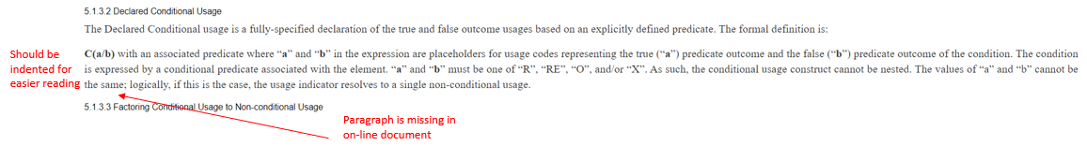

* This info is missing in Section 5.1.3.3

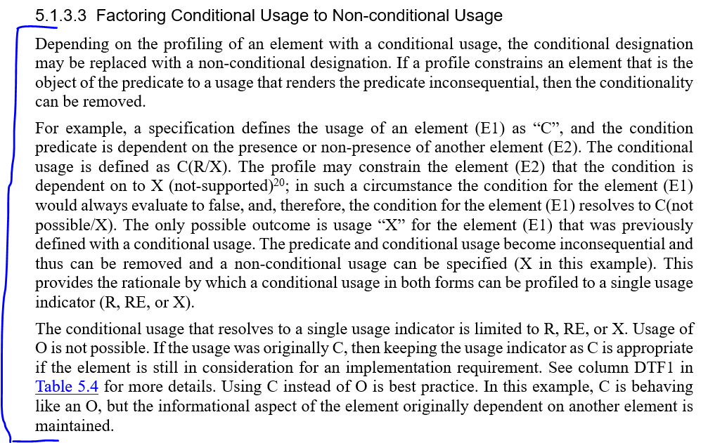

There now

* This verbiage under table 5.4 should be indented in on-line document

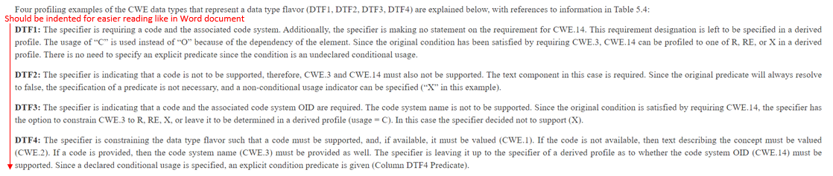

There now

* This info is missing in Section 5.1.3.4 in on-line document

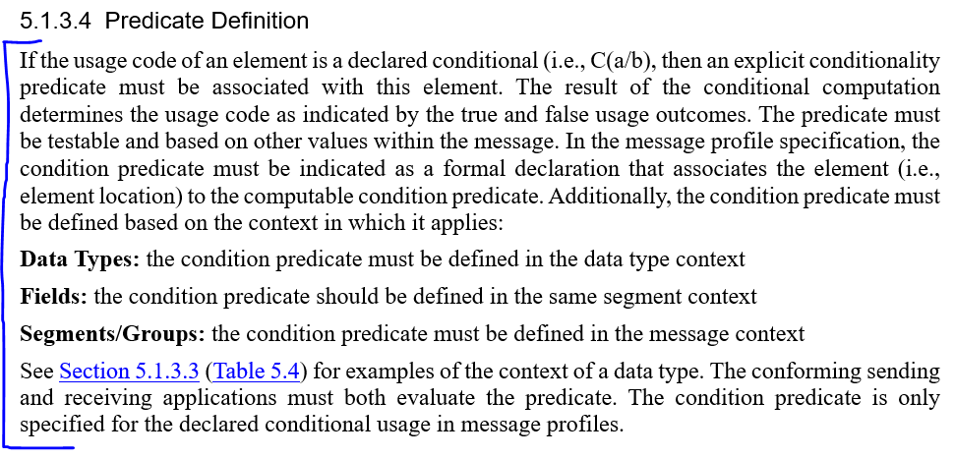

There now

* This info is missing in Section 5.1.4 in on-line document

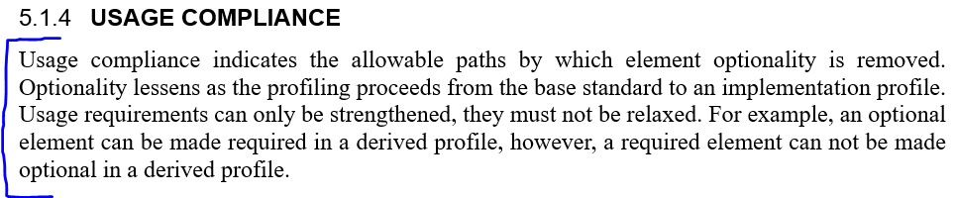

There now

* Table 5.6 in Word document is easier to read vs in on-line document…

|  |  |
| --- | --- |
|  |  |

* This info is missing in Section 5.2 in on-line document

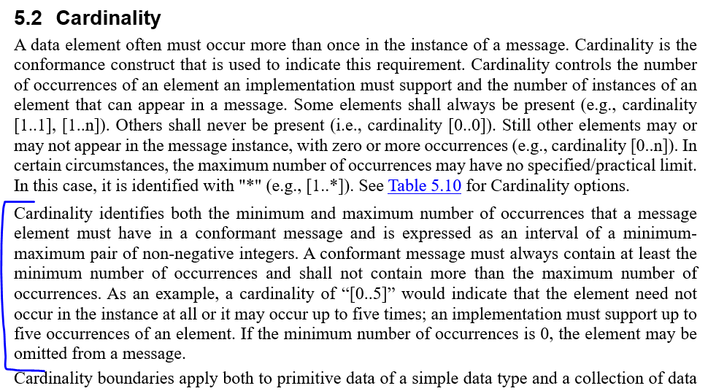

There now

* Table 5.10 in Word document is easier to read vs in on-line document…Word document uses page space more efficiently

|  |  |
| --- | --- |
|  |  |

* So much wrong here…compare info in Word document…

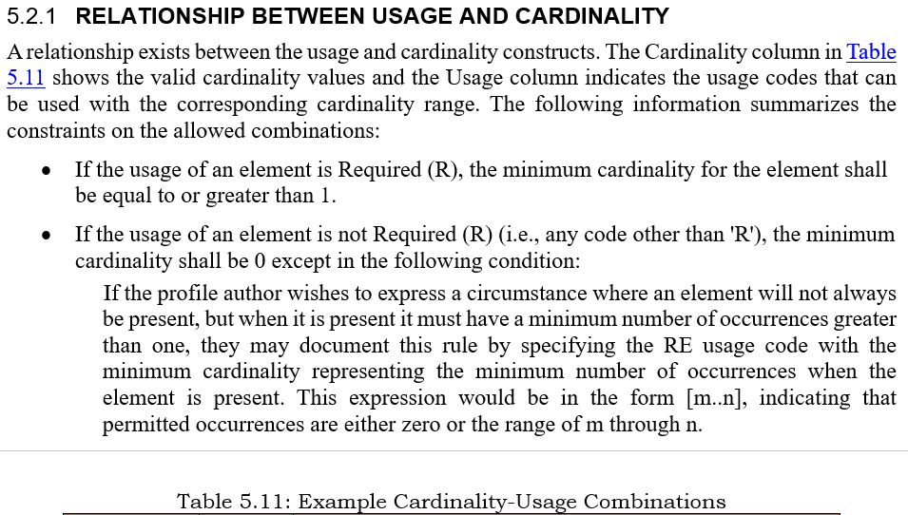

…to info in on-line document:

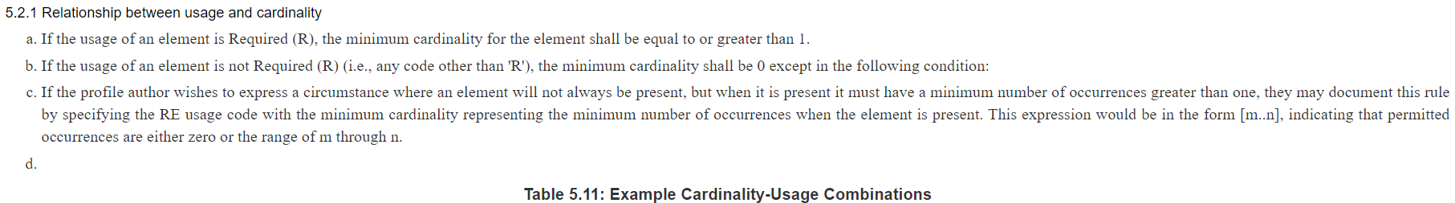

Better now – problem caused by incorrect styling in Word doc. Still needs some manual fix for part indented under second bullet.

* This info is missing in Section 5.4 in on-line document

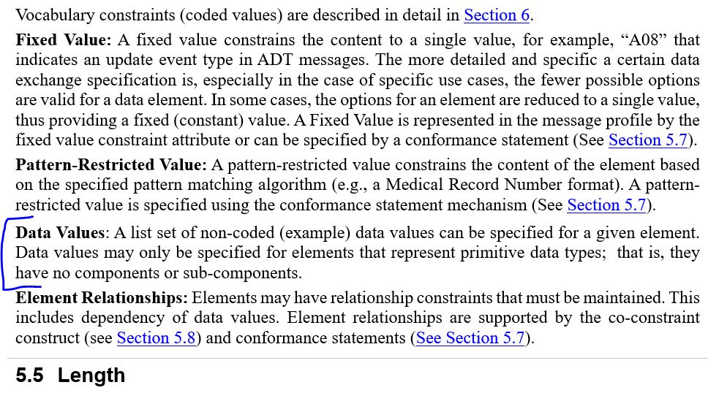

There now

* This info is missing under Table 5.15 in on-line document

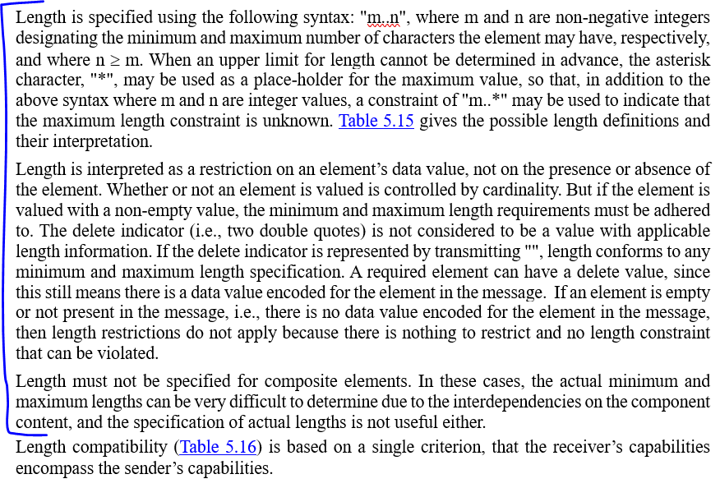

There now

* This info is missing in on-line document

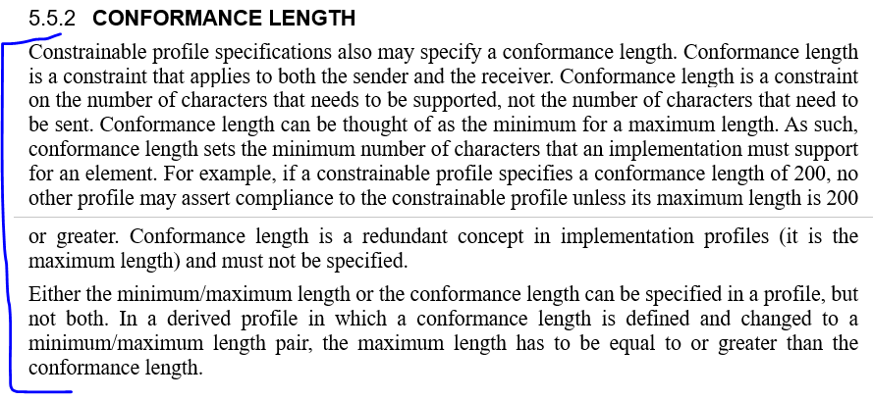

There now

* This info is missing in on-line document

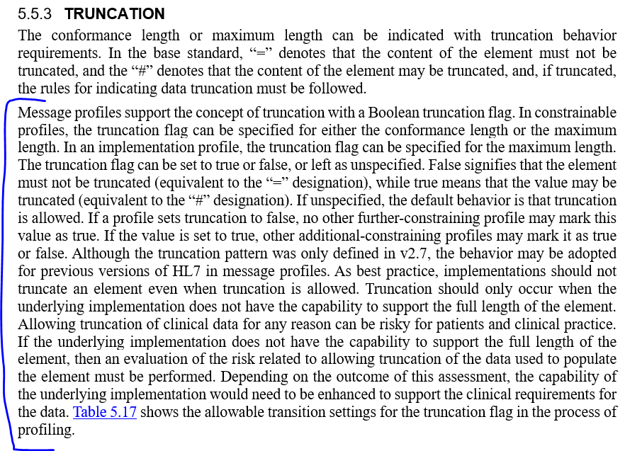

There now

* This section is not formatted properly (with bullets) in on-line document:

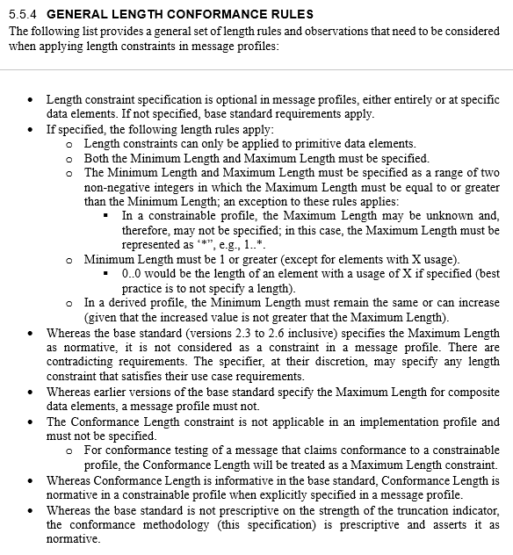

FIXED

* This info is missing in on-line document

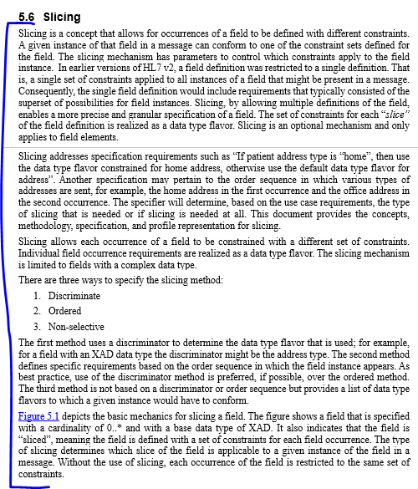

There now except with bulleted list instead of numbered list. FIXME

* This info is missing in on-line document

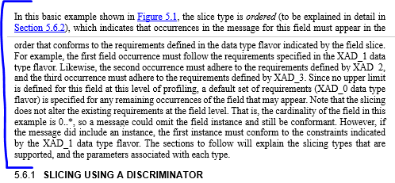

There now

* Info in Word document vs in on-line document…

|  |  |
| --- | --- |
| Word Document | On-line Document |
|  |  |

* Info in Word document is indented, but is not indented in on-line document…

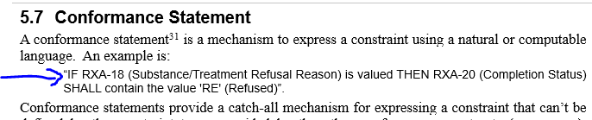

Fix Manually

* This info is missing in on-line document

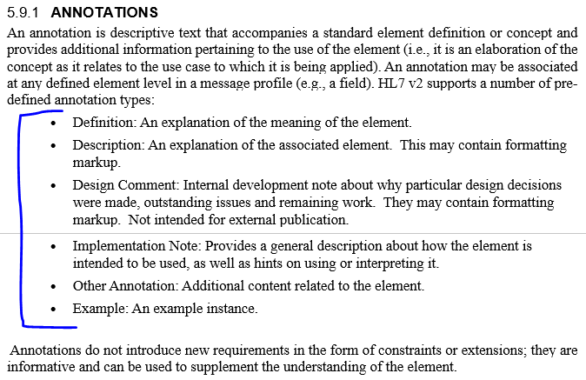

There now

**Issues with navigation of Sections**

* Menu bar displays when a main Section is selected, as shown here:

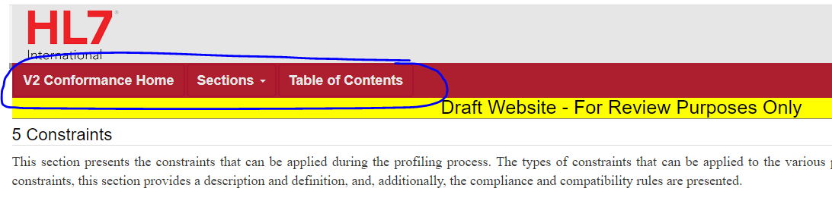

* Menu bar does not display when a sub-Section is selected, as shown here, which makes navigation cumbersome when moving from a sub-Section to another part of the document:

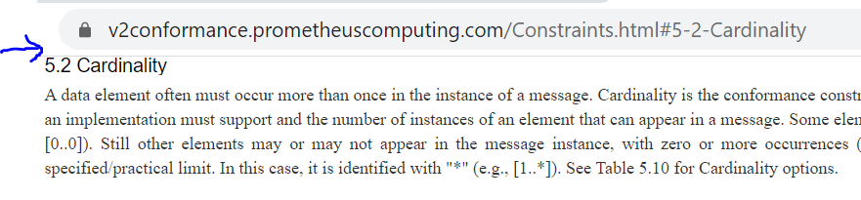

* “Sections” tab freezes when these Sections (6 & 10) have been displayed:

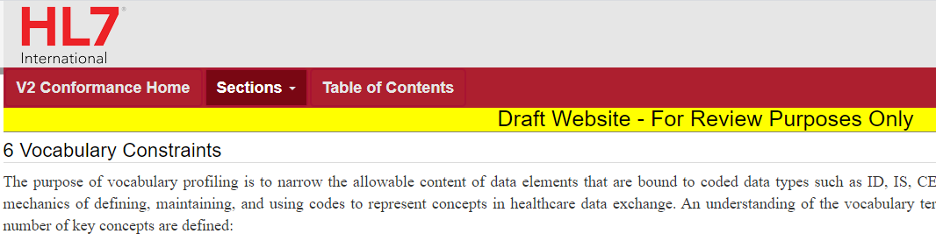

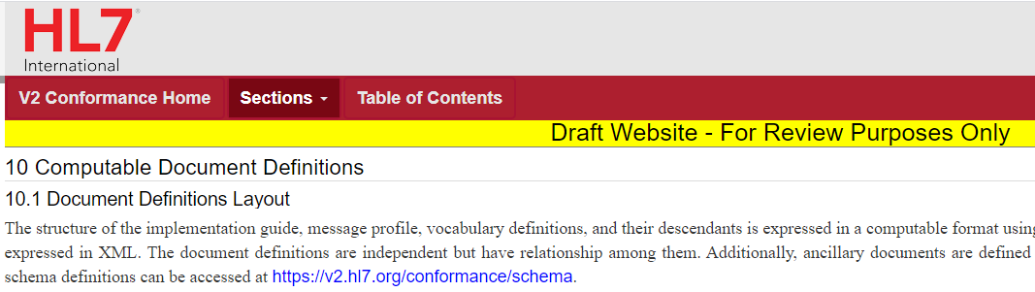

**Issues with navigation of Table of Contents**

* Menu bar displays when a main Heading in the ToC is selected, as shown here:

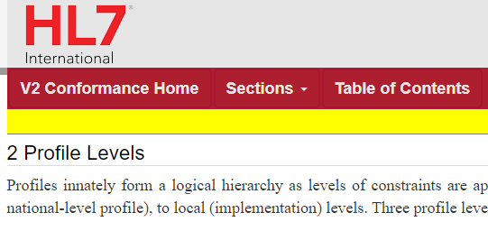

* Menu bar does not display when a sub-Heading of the ToC is selected, as shown here, which makes navigation cumbersome when moving from a sub-Section to another part of the document:

